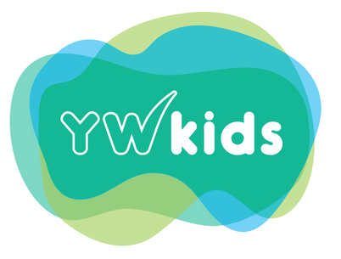

YW KIDS FEE SCHEDULE
Active April 1st, 2025

Full Time

$326.25
Infants: 0 - 18 months

Toddlers: 19-35 months

Pre-School: 3 – 4.5 years

ECS: 4.5 – 6 years

- Affordability Grant is applied to the full time

